Bakewell OCPI user guide

This user guide is created for Bakewell OCPI user and designed to guide Bakewell OCPI user to use the accompanied *Imagine* software.

1. Before starting your experiment, it is strongly suggested to check the status of the mechanical moving stage of the Bakewell OCPI. The mechanical moving stage used in Bakewell OCPI can be in ***IDLE*** (non-reponsing) status if the *Imagine* software or the stage controller software is shutdown abnormally.

First, close the *Imagine* software and all other softwares whose name starting with “APT”.

Start ***“APT User”*** 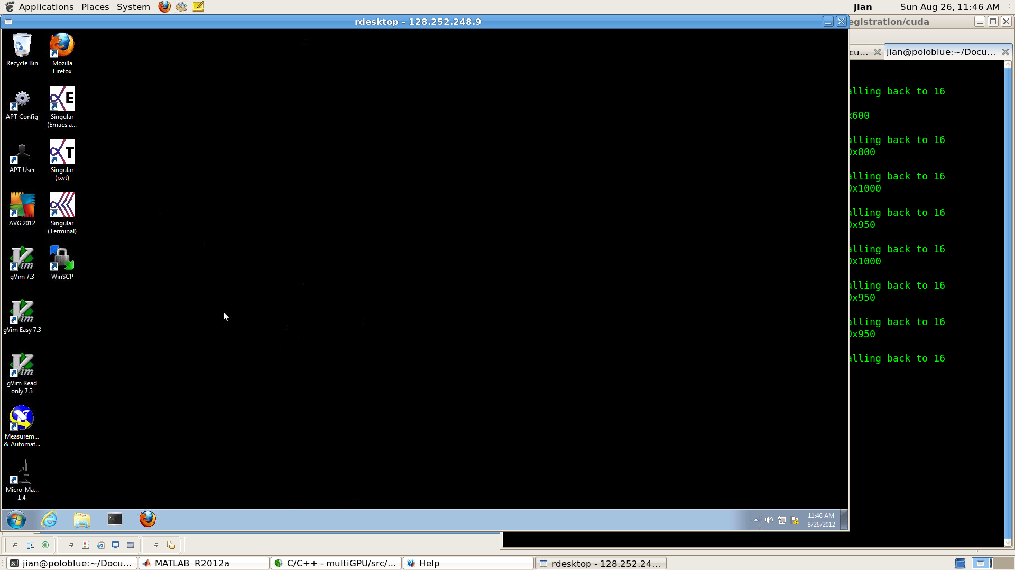 software from desktop.

If the response looks like this,

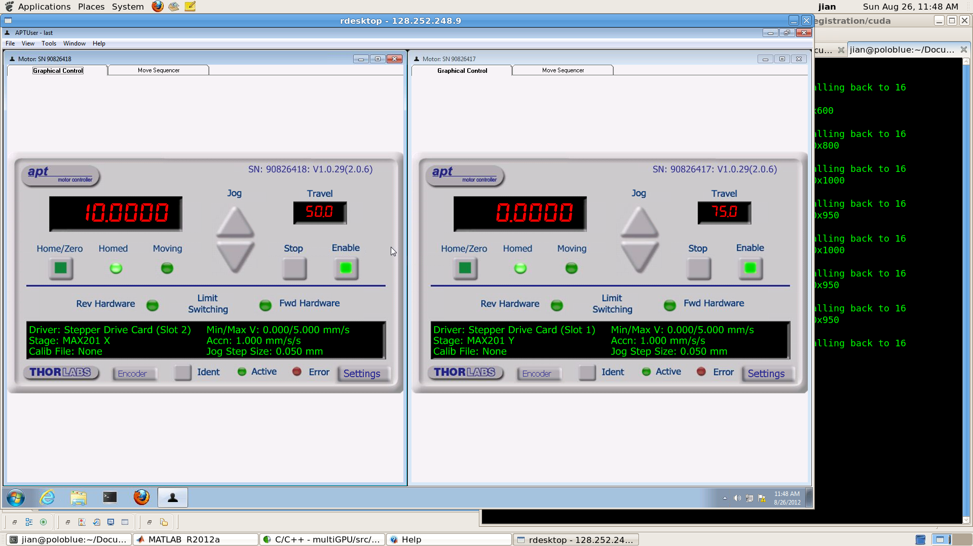

it indicates that the moving stage is working properly. Close the APT software. If the software asks you to save or not, choose “not”. You can now skip and proceed the next step. Otherwise, restart the moving stage by pressing the power button (located on the top part of the shelf on your back, a picture here) off and on (10 seconds time gap required). Restart the computer. After these, start ***“APT User”*** software again and make sure you can see the picture above.

2. Rotate the scew next to the camera and lift up the camera to avoid any damage to the camera lens (a picture here to indicate where the screw and camera lens are). Do not put your sample on the stage.

3. Start ***“imagine2.exe”*** from desktop. The software should look like this,

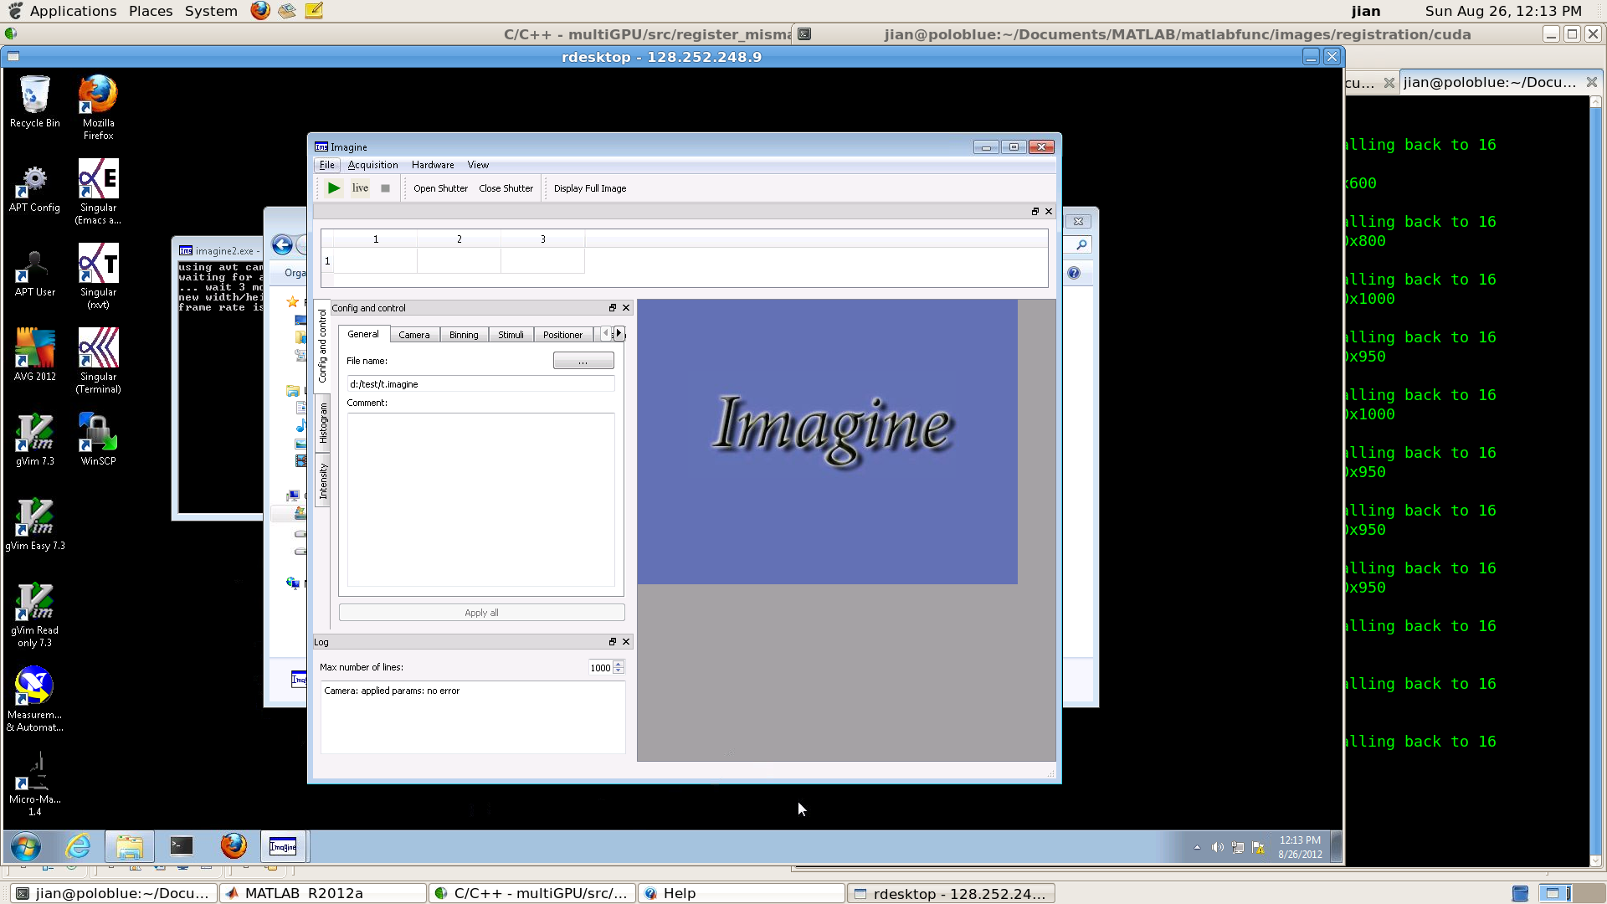

4. In “General” tab,



set up the ***“File name option”*** and ***the location*** where this recorded image should be saved.

It is suggested to save the recorded image only in R:/ partion. For instance, R:/Holy/Gary/test.imagine. Please create your own folder in R:/ partion to save your own data. The file name must be named using *.imagine format. Keep the .imagine extension.

Click ***“Apply All”*** right after chaning the file name.

5. In “Camera” tab,

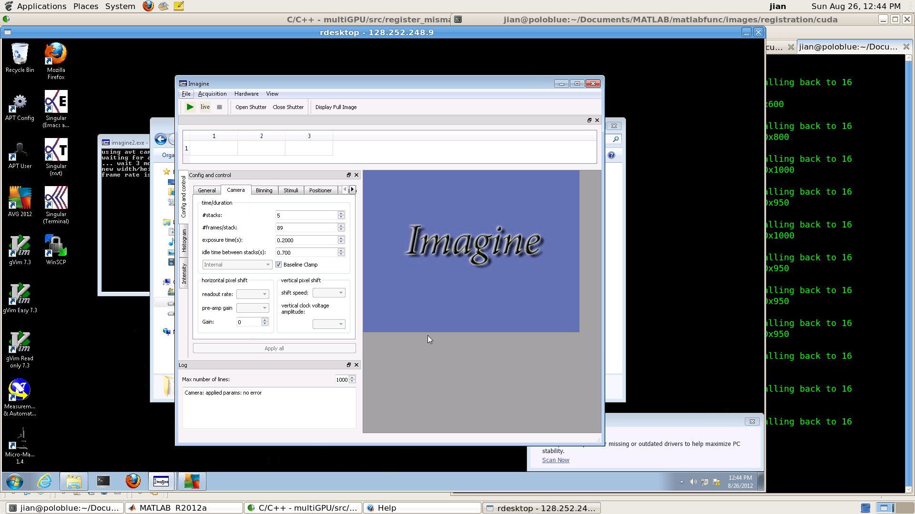

***“# stacks option”*** sets the number of the repeated scanning.

***“# frames/stack option”*** sets the number of image frames taken per scanning stack.

***“exposure tims(s) option”*** sets the exposure time of each image frame.

***“idle time between stacks(s) option”*** ?????

The time ***T*** for the stage to scan the sample from the start position to the stop position in each stack is equal to

T = #frames/stack * exposure time

Click ***“Apply all”*** after finishing chaning parameters in this tab.

6. In “Positioner” tab,

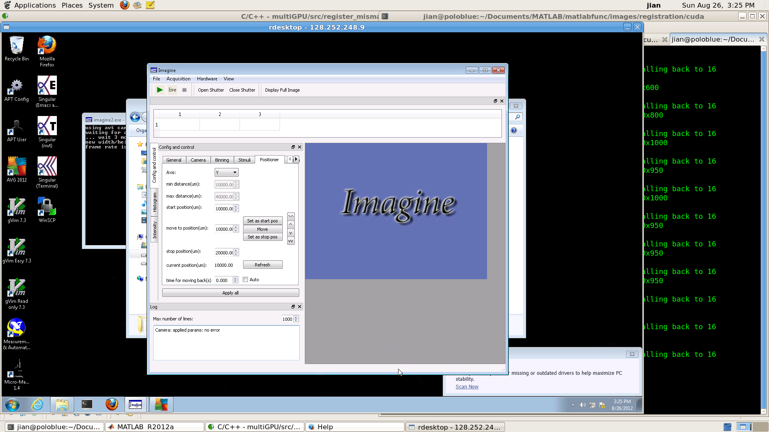

***“Axis option”*** sets the current moving axis. The stage can move in both X and Y axis, but can only scan in the Y axis.

***“min distance(um)*** *&* ***max distance(um)******options”*** display the minimum & maximum position value that the start & stop position can be.

***“start position(um) option”*** sets the start position of the scanning in unit of um.

***“move to position(um) option”*** sets the position for the stage to move to. This value must be within the range set by ***“min distance(um)*** *&* ***max distance(um)******options”.*** After setting this value, click ***“Move”*** to move the stage to the desired position.

***“stop position(um) option”*** sets the stop position of the scanning in unit of um.

***“current position(um) option”*** displays the current position. Press ***“Refresh”*** button to update this value.

***“time for moving back(s) option”*** sets the time for the stage to move back to the scan beginning position after one scanning movement. The stage controller code has already hard-coded the optimized parameters for this movement. It is suggested to choose ***“Auto option”*** to use these optimized parameters instead of setting your own time.

Click ***“Apply all”*** to apply the changes.

One ***important*** detail about the stage movement and the stage controller code design is described here. In order to make the stage move at a ***constant*** speed in between ***the*** ***start position*** and ***the stop position***, ***an acceleration length*** and ***a deceleration length*** are added before ***the start position*** and after ***the stop position***. The value of the ***acceleration length*** and the ***deceleration length*** is the same and is calculated as described below.

The stage moves at speed V in between the ***start position*** and the ***stop position***,

V = [abs(stop position – start position) / 1000.0 ] / [#frames/stack * exposure time]

The ***acceleration length*** and the ***deceleration length*** is equal to

L = 4.0 * V^2 / A

where A is the acceleration rate which is 1.0 mm/s^2.

Suppose the stage moves at 1.0 mm/s in between the start position and the stop position, the acceleration length and the deceleration length will be equal to

4.0 mm.

If the start position and the stop position are set to be 10.0 mm and 20.0mm, in each scanning the stage will actually start from 6.0mm, accelerate and reach the constant speed 1.0mm/s before the 10.0 mm start position, scan from 10.0mm to 20.0mm at this constant speed, decelerate after the 20.0 mm stop position and then decelerate and stop at 24.0mm, move back to 6.0mm at 1.1mm/s speed and then repeat the scanning.

Please make sure that for the camera & positioner parameters set by user, the stage velocity is no bigger than 1.1 mm/s. If the error message window pops out after clicking the “Apply all” button, please double check and make sure all the input parameters are appropriate as described above.